Apex Service with ORM stack

Contents

1. Introduction 3
2. Workflow diagram to deploy the stack 4
3. Create stack for Apex Service: 5
4. Plan the Job 9

Introduction
Apex is a managed service provided by Oracle Cloud Infrastructure (OCI) that allows you to build, deploy, and manage serverless functions. It provides a serverless computing platform, enabling developers to focus on writing code without having to worry about infrastructure management.
Here are some key features and capabilities of Apex in OCI:

Function as a Service (FaaS): Apex allows you to write functions in various programming languages such as Node.js, Python, and Java. These functions can be triggered by events, such as HTTP requests, object storage changes, or scheduled timers.

Seamless Integration: Apex functions can easily integrate with other OCI services, including Oracle Object Storage, Oracle Database, and Oracle Streaming Service, allowing you to build powerful serverless applications.

Automatic Scaling: Apex automatically scales your functions based on incoming requests and the configured concurrency limits. This ensures that your application can handle varying workloads without manual intervention.

Pay-as-you-go: With Apex, you only pay for the resources consumed by your functions, such as execution time and memory usage. There are no upfront costs or long-term commitments.

Monitoring and Logging: Apex provides built-in monitoring and logging capabilities, allowing you to track the performance and behavior of your functions. You can view metrics, set up alarms, and analyze logs to troubleshoot any issues.

Security and Access Control: Apex functions run within a secure execution environment and can be configured with fine-grained access controls. You can control access to your functions and their associated resources using IAM policies.

Developer-friendly: Apex supports popular development tools and frameworks, such as the Oracle Cloud Infrastructure CLI, SDKs, and Terraform. This makes it easy to integrate Apex into your existing development workflows.

Workflow diagram to deploy the stack

Below diagram shows how the Terraform Artifact are applied in the OCI. While creating a ORM stack, using terraform deliverables Init, Plan and Apply is the flow to provision the resource in the OCI. We can have the deliverables in any of below.

- GitLab/GitHub Repo
- Bitbucket
- Can be in folder/.zip in the local disk
- Object Storage Bucket
- Can be in compartment
- Oracle provided Template


Create stack for Apex Service:

Go to OCI Console Developer Services Resource Manager Stacks select the compartment Create Stack

My Configuration Folder Browse Select the “Apex service” folder that contains the terraform Upload

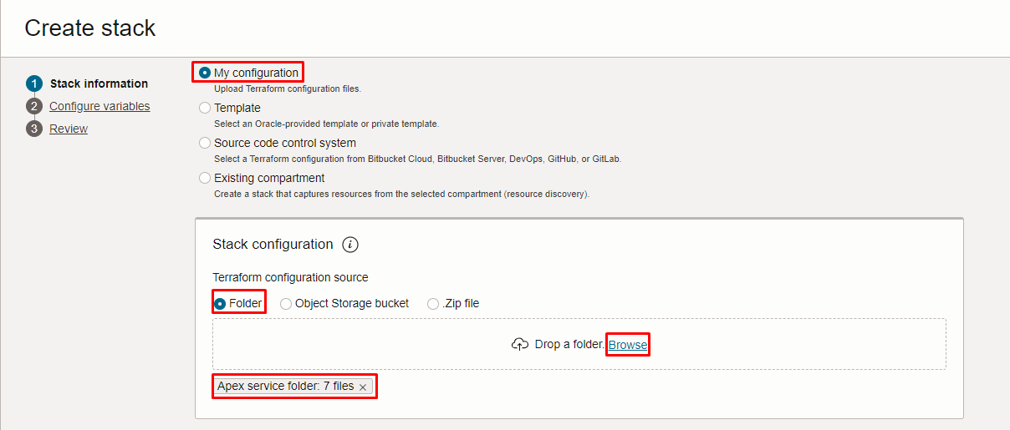
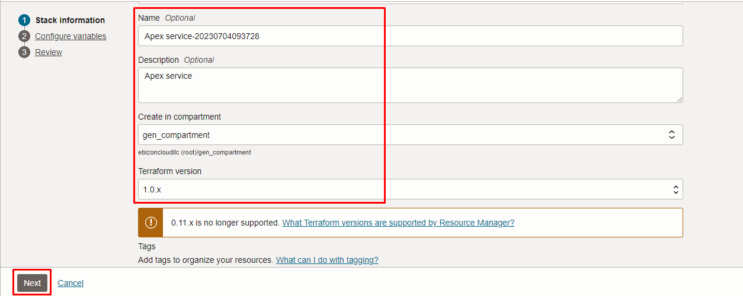

Click “NEXT”
Select the parameters as per the below screen,
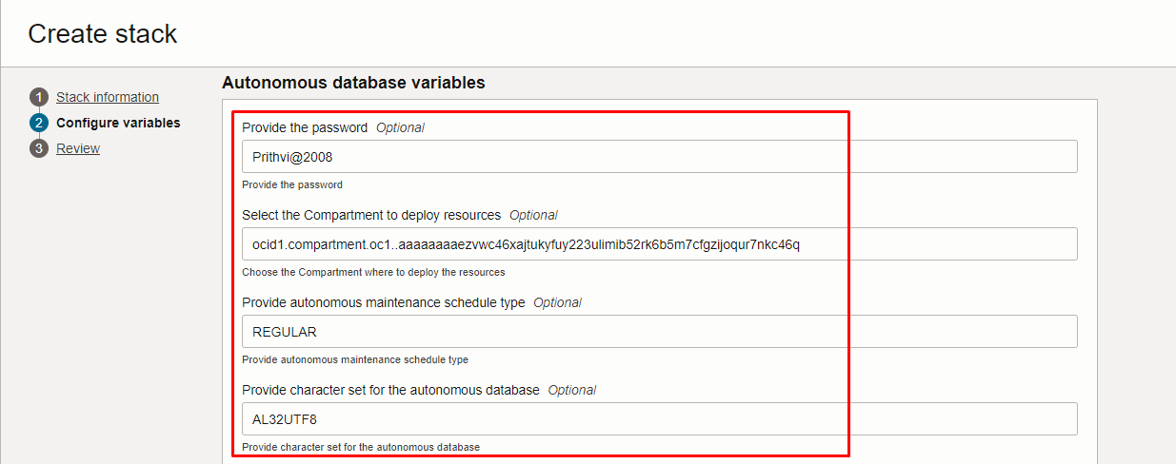

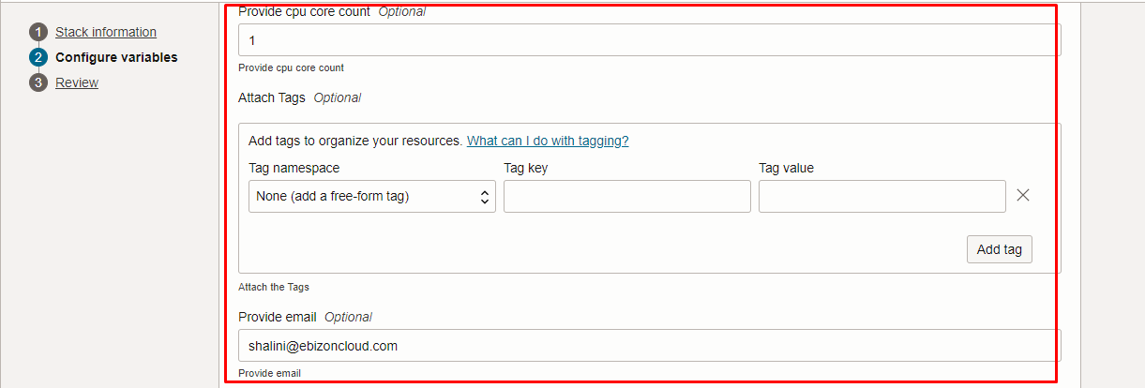
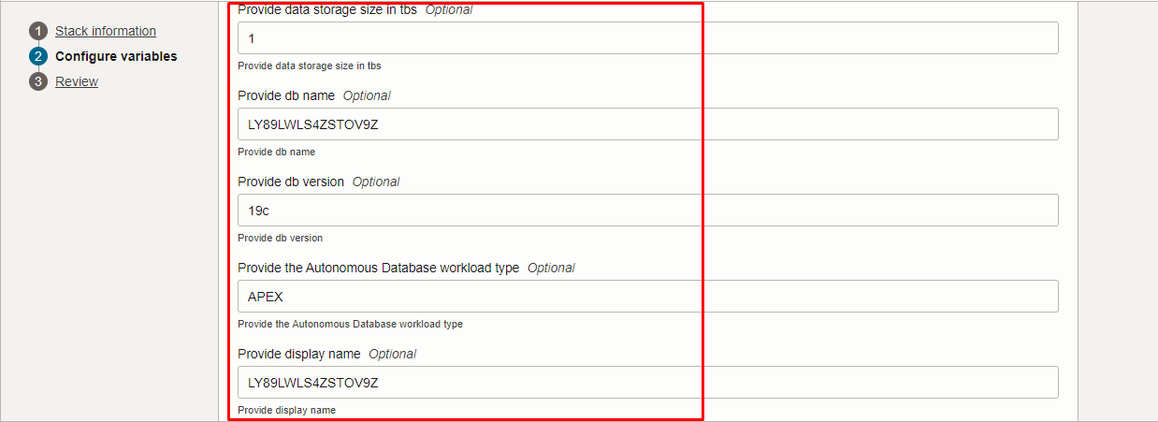
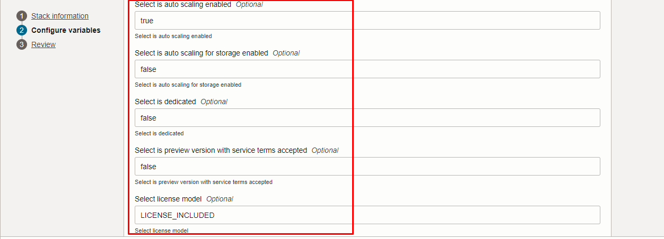
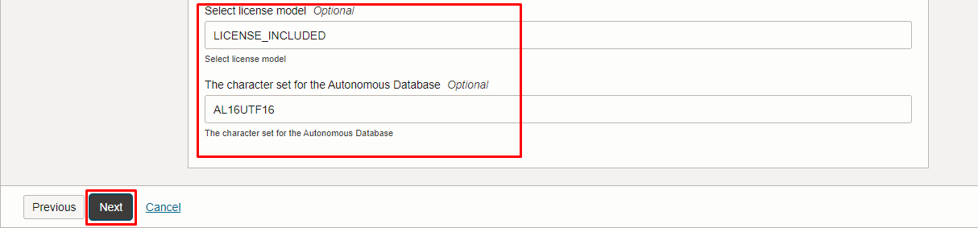
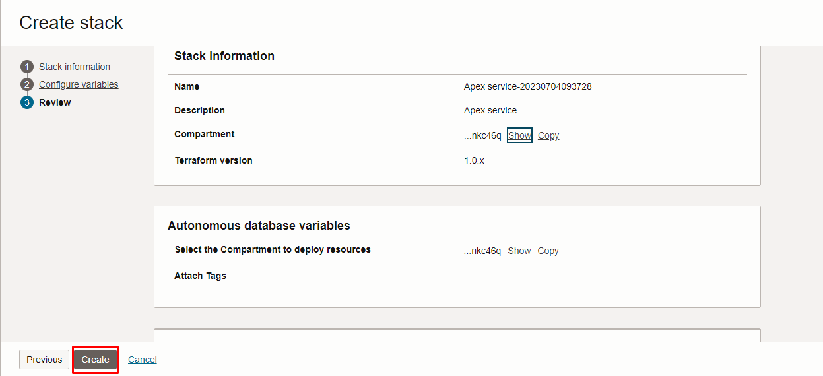

Click “NEXT” Click “CREATE”

Plan the Job

Click the “Plan”
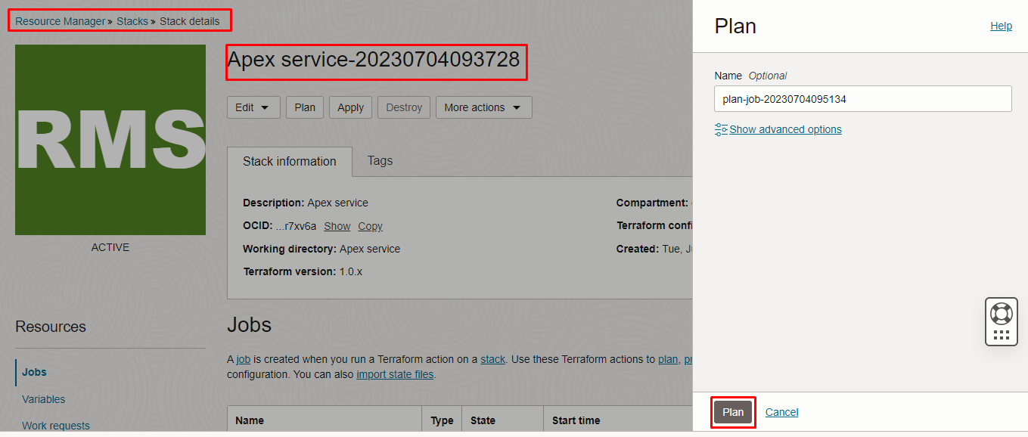

Verify the Plan is successful.

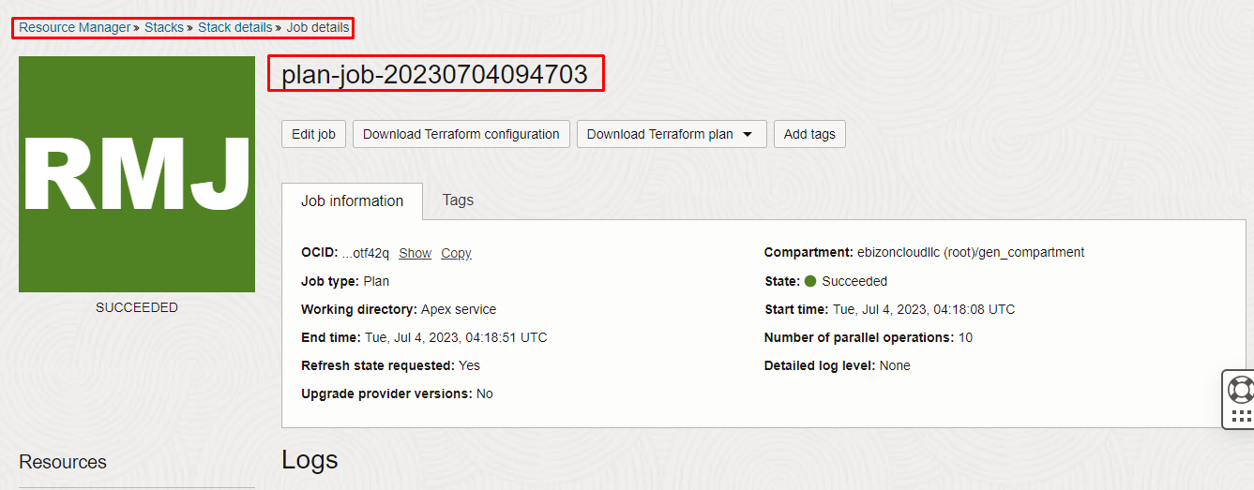
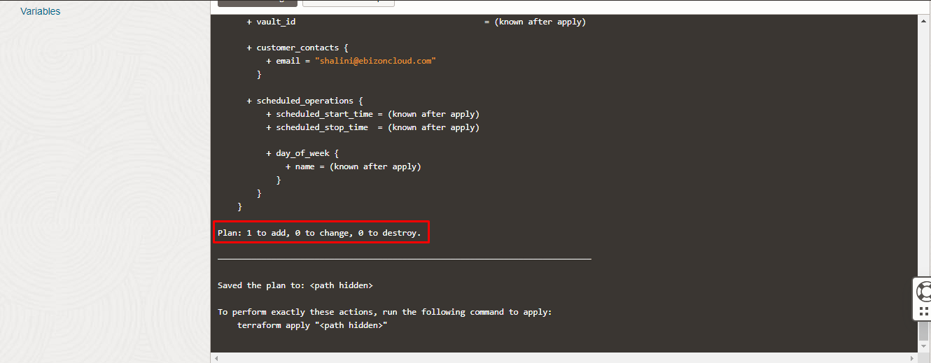

**END**

